

**Tribhuvan University**

**Texas International College**

**A Final Year Project Report**

**On**

**SLATE**

**Under the Supervision of**

**Mr. Rom Kant Pandey**

**Asst. Prof., Central Department of CSIT, TU**

**Submitted To:**

**Department of Computer Science and Information Technology**

**Texas International College**

**In partial fulfillment of the requirement for the Bachelor Degree in Computer Science and Information Technology**

**Submitted By**

**Aman Maharjan (15563/074)**

**Pushpa Pandey (15591/074)**

**Upendra Adhikari (15605/074)**

**December 20, 2021**

**SUPERVISOR’S RECOMMENDATION**

I hereby recommend that the report prepared under my supervision by **Aman Maharjan (TU Exam Roll No. 15563/074), Pushpa Pandey (TU Exam Roll No. 15591/074)** and **Upendra Adhikari (TU Exam Roll No. 15605/074)** entitled “**SLATE**” in partial fulfillment of the requirements for the degree of B.Sc. in Computer Science and Information Technology be processed for evaluation.

---------------------------------

**Mr. Rom Kant Pandey**

Asst. Professor,

Central Department of CSIT

Tribhuvan University

Kirtipur, Nepal

**CERTIFICATE OF APPROVAL**

This is to certify that this project prepared by **Aman Maharjan (TU Exam Roll No. 15563/074), Pushpa Pandey (TU Exam Roll No. 15591/074)** and **Upendra Adhikari (TU Exam Roll No. 15605/074)** entitled “**SLATE**” in partial fulfillment of the requirement for the degree of B.Sc. in Computer Science and Information Technology has been well studied. In our opinion, it is satisfactory in the scope and quality as a project for the required degree.

--------------------------------------------- **Mr. Rom Kant Pandey**

Project Supervisor

Asst. Professor, Central Department of CSIT Tribhuvan University, Kirtipur, Nepal

------------------------------------------------

**- Mr. Kumar Poudyal**

HoD, Department of CSIT

Texas International College

Chabahil, Kathmandu

-------------------------------------

External Supervisor

HoD, Asst. Professor, Central Department of CSIT

Tribhuvan University

Kirtipur, Nepal

**ACKNOWLEDGEMENT**

The success and outcome of this project were possible by the guidance and support from many people.I am incredibly privileged to have got all this along with the achievement of the project.It requires a lot of effort from each individual involved in this project with me and I would like to thank them.

So hereby, I would like to thank the BSc.CSIT department(TU) for giving us such a wonderful opportunity to expand my knowledge and giving us guidelines to present this report. It helped us a lot to realize what we study for. A special thanks goes to constant support from our respective supervisor **Romakant pandey** and **Texas International College BSc. CSIT** department head **Mr. Kumar Poudel** and the department itself, which helped us successfully complete our project.

We also have to appreciate the guidance given by other teachers as well as the panels especially in our project presentation that has improved our presentation skills thanks to their comments and advice.

**ABSTRACT**

Slate is a web based collaboration as well as learning platform for any kind of user to directly interact with the group or an individual by the group formation and video chats also with the integration of Whiteboard with its drawing tools specifically with a core feature of data optimization .We tend to use one of the prime ‘MERN stack’ besides using individual algorithms. The software has been designed with HTML5,CSS3 & REACT JS with MUI as frontend, NODE JS & MONGODB as backend system and Socket.IO for communications.

The main objective of our project is to provide an information sharing , communication as well as learning platform and delivering a concept of Whiteboard and also to reduce the data usage by using numerous algorithms based on data optimization such as LZW compression algorithm and also to provide a user friendly UI for anyone across the globe

Various tools and technologies are used for the development of the application. The software model is based on the Agile model (extreme programming). As for the tools, we have used software like Git, Zira, Balsamiq,etc.

For now the system is made for all types of browsers so that you don't have to download to use it.The system can be made more advanced in future with more features such as QA assignment attendance system and also can be built for android and iOS.

**Table of Content**

**Chapter 1 : Introduction** **3**

1.1 Introduction 3

1.2. Problem Statement 4

1.3. Objectives 4

1.4. Scope and limitation 4

i. Geographical Scope and User Scope 4

ii. Technical Scope 4

1.5.Development Methodology 5

1.6. Report Organization 5

**Chapter 2 : Background Study and Literature Review** **7**

2.1 Background Study 7

2.2 Literature Review 7

**Chapter 3: System Analysis** **9**

3.1. System Analysis 9

3.1.1. Requirement Analysis 9

i. Functional requirements 9

ii. Non-functional Requirements 10

3.1.2. Feasibility Analysis 11

i. Technical Feasibility 11

ii. Operational Feasibility 12

iii. Economic Feasibility 12

iv. Schedule (Gantt chart showing the project timeline) 13

3.1.3. Analysis 14

i. Object modelling using Class and Object Diagrams 14

ii. Dynamic modelling using State and Sequence Diagrams 15

iii. Process modelling using Activity Diagrams 16

**Chapter 4: System Design** **17**

4.1. Design 17

4.1.1. Object modelling using Class Diagrams 18

4.1.2. Dynamic modelling using State and Sequence Diagrams 19

4.1.3. Process modelling using Activity Diagrams 20

4.1.4. Component Diagram 21

4.1.5. Deployment Diagrams 22

4.2. Algorithm Details 23

4.2.1. LZW compression algorithm for data optimization 23

i. LZW ENCODING PSEUDOCODE 23

ii. LZW DECODING PSEUDOCODE 24

**Chapter 5: Implementation and Testing** **25**

5.1. Implementation 25

5.1.1. Tools Used 25

**References:** **26**

**LIST OF FIGURES**

* **Figure 1. Use Case Diagram**
* **Figure 2. Monthly gantt chart view of project schedule**
* **Figure 3. Object Modelling using Class diagram**
* **Figure 4. Sequence diagram**
* **Figure 5. Process Modelling Activity Diagram**
* **Figure 6. Object Modelling using Class diagram**
* **Figure 7. Sequence diagram**
* **Figure 8. Process Modelling Activity Diagram**
* **Figure 9. Component Diagram**
* **Figure 10. Deployment Diagram**

**LIST OF ABBREVIATIONS**

**LZW -** Lempel-Ziv-Welch

**PIECES -** Performance Information Efficiency Control Economics Services

**UNESCO -** United Nations Educational, Scientific and Cultural Organization.

**ICT -** Informations And Communications Technology

**UI -** User Interface

**MERN -** MongoDB Express React NodeJs

**TV -** Television

**CASE -** Computer-aided software engineering

**PIECES -** Performance Information Efficiency Control Economics Services

**CSS -** Cascading Style Sheet

**HTML -** Hypertext Markup Language

**SASS -** Syntactically Awesome Style Sheets

# Chapter 1 : Introduction

## 1.1 Introduction

Evolution in technology is essential to unravel the problems and challenges in the world.Also,we are constantly evolving as we are interacting with the world.So,in the account of this, it all began when there was the most perilous pandemic of Novel Coronavirus, also known as COVID-19 which has disrupted many aspects of human life, including education. According to a UNESCO report , 1.6 billion children across 191 countries have been largely impacted by the temporary closure of educational institutions. To mitigate this impact, many educational institutes have responded with their own way of solution .Most solutions included ICT technology in order to provide continuity in educational activity. As online education relies on technology which includes the internet and Wi-Fi, the discrepancies that exist in their availability are widening the gaps in access and quality of education. Government also tries to use traditional technologies such as radio and TV but when it comes to learning one way communication is not enough.The pandemic has had serious impacts on students’ learning and well-being, and that it potentially widens the gaps between advantaged and disadvantaged children in their equitable access to quality education.

On account of that we have lined up a scheme designed to compose a strong ,light and effective platform for participation and communication between two or more remotely placed individuals or groups named Slate. The main feature of our product Slate is to provide a learning platform for any kind of user to directly interact with the group or an individual by use of Whiteboard along with its drawing tools specifically with a core feature of data optimization not to be overlooked. We tend to use one of the prime ‘MERN stack’ besides using individual algorithms. We are providing students/or any kind of learning alacrity loaded groups of people with our special feature integrated Whiteboard where the individuals will get the latest facilities at the least uses of data packets where there won't be any issue of packet loss while accessing our Web App .So, overall Slate is a persistent chat-based collaboration platform complete with online meetings,group formation including video chat and many more extremely useful features for communications and learning.There certainly are quite a lot of options to choose from. But one particularly useful solution stands out and is not obsolete is : Slate.

## 1.2. Problem Statement

Concerning the current scenarios, our whole country is shifting to online education. In parallel, the current pandemic is impacting rural students more than those who live in cities. While many are making the most of what online learning offers, local authorities are finding it tough to integrate high-speed internet facilities. Furthermore, purchasing data plans for learning could also incur a lot of expenses for families who face financial constraints which have affected the participation levels of both teachers and students concerning live classes. So, to resolve this kind of problem we are introducing our web app i.e Slate, a free learning & interacting platform to settle the issue of data management while conducting the online interactions.

## 1.3. Objectives

The objective of this project is :

* To provide an information sharing , communication as well as learning platform and delivering a concept of Whiteboard.
* To reduce the data usage by using numerous algorithms based on data optimization
* To provide a user friendly UI for anyone across the globe

## 1.4. Scope and limitation

**Scope**

### i. Geographical Scope and User Scope

Our project is not going to be limited to one community , a district or a region, but for the whole nation . As we are targeting the rural audience who are behind the reach of excess data so it can definitely be utilized by urban sprawl.

### ii. Technical Scope

In contrast to traditional software systems, which are built using an homogeneous technology infrastructure, this system runs in a heterogeneous computing environment that includes multi-platforms, multi-browsers, and multimedia support. The system is designed in such a way that : system can be scaled according to the volume of the user using the system.

**Limitations**

The limitations of the system are:-

* Limited features are available in whiteboard ,
* Is only accessible via browser as we are working on web app for now,
* Storage is limited as we are using free resources for now

## 

## 1.5.Development Methodology

The Agile methodology is a style of project management that divides a project into phases. It's a project management method that entails ongoing collaboration and iteration, allowing to deliver value to clients more quickly and with fewer headaches. Small, digestible amounts of work can be produced with agile. Requirement plans and results are evaluated on a regular basis. Changes are progressive and evolutionary rather than revolutionary with user engagement, thus it can be useful in promoting change that is important to the success of most project transitions. As a result, the agile development methodology is a suitable decision.

## 

## 1.6. Report Organization

The report is based on six chapters. The project's resources, requirements, and diagrammatic representations are divided into six chapters. Each chapter follows the creation of our project from start to finish.

* The first chapter gives a general summary of our project. It foreshadows and includes key concepts that will be covered in the following chapters.
* The project's background study and literature evaluation are detailed in Chapter 2, which follows the introduction chapter. It enables you to distinguish between different hypotheses, strategies, and problems in the current investigation.
* The third chapter covers a lot of ground when it comes to system analysis. It includes a requirement analysis, a feasibility analysis, and object-oriented analysis. It outlines each experiment's goals and addresses the difficulties presented in Chapter 1.
* Depending on the method chosen in Chapter 4, the system design in Chapter 4 takes either a structured or an object-oriented approach. A structured strategy includes database design, forms and report design, as well as interface and dialogue design. However, an object-oriented technique is employed, which involves the refinement of class, state, object, sequence, and activity diagrams. Diagrams of components 4 and deployment are also supplied. This helps you understand the system design and algorithm that was used to create it.
* In Chapter 5, a number of CASE tools, as well as computer languages and database platforms, are briefly discussed. In this sub-topic, the implementation details of modules are defined. During the testing phase, unit and system testing are performed to assure accuracy. This chapter discusses the results of the tests.
* In Chapter 6, the project's findings and future recommendations are offered. This gives an indication of how the project will be evaluated as a success and what improvements might be made.

# Chapter 2 : Background Study and Literature Review

## 2.1 Background Study

The global pandemic has created a shift in how people work and learn a shift that will become the new normal as we all figure out how to function in a hybrid world. The last 2 years have seen the evolution of hybrid work develop into a reality being adopted across the globe. So we attempted our best to coordinate with Whiteboard with the online instruction with least amount of data packets loss & low bandwidth requirement additionally free of cost. Talking about the study perspective of this project, the Slate stroked into our mind just by observing the current havoc happening in the world. The situation of Covid is becoming a never ending part which is severely affecting the educational sector as well as student’s mentality.

So, the problem was discussed by observing the situation of children’s who are financially in reverse as well as distant from the reach of surplus data. Education is one of the foremost imperative portions of our life after our prosperity and wellbeing. Even Though the people living inside the city areas may not find it difficult to attend the online classes in these difficult situations, by observing the situation of the children’s of rural areas through various mediums such as televisions, radios and even by our own research we discovered the circumstance exceptionally vital. Some children’s are finding a different way. For instance, we might have heard the news of a child who built a house on the tree for his online class due to network problems as well as the platform where he or any other children get that from might consume a lot more data bandwidth. For that he is risking his life. As a matter of concern we have decided to build such a light weighted learning platform which consumes less data as compared to existing software’s such as MS Teams, Zoom and many more also with integrated Whiteboard interior in it.

## 2.2 Literature Review

As mentioned above , there are numerous platforms that benefit peoples in the real world by the aid of virtual meetings also considering the education sector . As far as our concern , there are few platforms which tumble under our research section considering the similar concepts with our project. One of them is Zoom. Zoom was originally founded in 2011.Zoom had gained 2.22 million users in 2020 – more users than it amassed in the entirety of 2019 with the company's share price spiking by 35 percent.The pandemic has kickstarted this system in a wide range.At the same time Zoom has been criticized for "security lapses and poor design choices" that have resulted in heightened scrutiny of its software.

Getting into another similar kind of software, Microsoft Teams is also widely time-honoured software.Microsoft announced Teams at an event in New York, and launched the service worldwide on March 14, 2017. It was created during an internal hackathon at the company headquarters . Microsoft Teams is simply the collaboration app that brings together all the diverse functionalities and tools in one place for simple communication, fast collaboration and widespread integration with external apps and bots.

By studying existing systems such as Zoom ,Teams, even Facebook and Viber we find out that most of the system consists of some of the use cases that are implemented in the Slate.Some got some security issues while others got more complex to normal users. There are so many of them yet users are still very much confused as to which one they have to use in different circumstances. So it is not the axiom that if there exists some sort of system that already existed then, there also can be similar kind of improvised system which may appeals better also.We can take the good example from facebook .Although, there already was Facebook universally accepted but eventually new softwares such as Instagram , Twitter ,Whatsapp get positioned in the market successfully. Likewise our system has features tending to solve the big rising issue namely digital divide as it is mostly concerned with the bodies that are behind the reach of excessive datas commonly in remote areas .To overcome this problem our web application will have an interactive whiteboard where both teacher and student can interact by optimizing the data needed for online communication along with features of traditional learning platforms like sharing video and other resources.

# Chapter 3: System Analysis

## 3.1. System Analysis

### 3.1.1. Requirement Analysis

E-learning has evolved over the last few years from being a supplementary tool to becoming an essential companion to teaching , however many platforms that provide these services do not provide tools that student and teacher want for betterment of the class or learning. Taking that in mind we conducted an online survey for the requirement analysis of this platform and found out different features are provided in different platforms but there is not any good platform to provide all of the services and tools which are necessary for the effective class. This gathering requirement aids in determining our users demands, determining project size, and determining the timeframes and resources required to finish the project.

#### i. Functional requirements

Following are the functional requirements of the system:

* User Registration and Authentication
* Email verification
* Chat (Group chat)
* Group video Calling
* Whiteboard with drawing tools
* Invite participants through Email
* User profile (Profile picture,Password change)

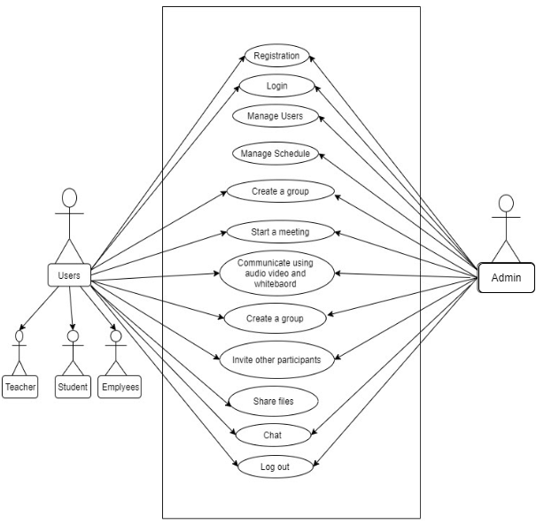

**Figure 1. Use Case Diagram**

#### ii. Non-functional Requirements

**a. System Reliability Requirements:**

* The system must be dependable.
* If the request cannot be processed, an appropriate error message will be displayed.
* Web pages load in a matter of seconds.

**b. Requirements for safety:**

* It is necessary to keep track of the specifics.
* Authentication of users is required.
* The database must be backed up on a regular basis.

**c. Requirements for security:**

* The user can view his profile after providing his password and user id.
* The user's information must be kept safe and secure.
* Details are shared.

**d. Requirements for data optimization**

* The main goal here is to optimize the data which is major non functional requirement (Please suggest us appropriate algorithm or method)

### 3.1.2. Feasibility Analysis

#### i. Technical Feasibility

As this system is completely web based. So hereby implementation and working of this system is technically feasible on any devices with any modern browsers. This application requires a minimum of Windows XP platform with a high configuration of 1GB RAM and an Intel Pentium Dual Core CPU. This is technically doable.

**Frontend and Backend Technology**

* Balsamiq
* HTML5
* CSS3
* Sass
* Material UI
* React.js
* Express.js
* Node.js

**Database**

* MongoDB

**Diagram drawing tools**

* Draw.IO
* Gleek.IO

Each of the above mentioned technologies are freely available and our team has the technical skills required to develop the project. Implementation of this project is within the time limitations of the development. For now, the website is hosted in a free web hosting space, but for later implementations it will be hosted in a paid web hosting space with sufficient bandwidth. From these it’s clear that the project is technically feasible.

#### 

#### ii. Operational Feasibility

The proposed system follows the PIECES framework which helps in identifying problems to be solved and their urgency so that new participants can have ease excess on our system:

**Performance**: With the implementation of lazy loading, database normalization the system provides adequate throughout and response time.

**Information**: The system includes optimized form to get maximum information which provides end users and managers with timely, pertinent, accurate, usefully formatted information.

**Economy**: For now.the system is hosted in a free hosting system to provide cost effective information to the service.

**Control**: To offer effective controls to protect security of data and information of the users the system collects user details for user identification and verification.

**Efficiency**: This system maximizes the use of available data and resources.

**Services**: The proposed system is initially in testing phase with a limited area and later will grow globally. So, the system will provide reliable service and will be flexible and expandable for future work.

#### 

#### iii. Economic Feasibility

Tools and technology for implementation of this system include:

* MERN stack for the development
* MongoDB as database

The MERN stack that is mentioned above is an open source stack for web development . As a database using MongoDB we get free space upto 250 MB in MongoDB atlas where we stored our data in NoSql file based format. Hence all technology is freely available to develop the project initially the web site is hosted in a free web hosting space. So, the system is economically feasible.

#### iv. Schedule (Gantt chart showing the project timeline)

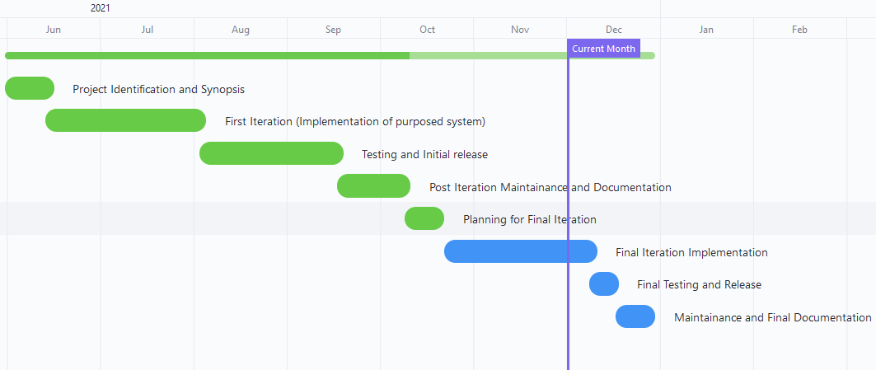

**Figure 2. Monthly gantt chart view of project schedule**

### 3.1.3. Analysis

#### i. Object modeling using Class and Object Diagrams

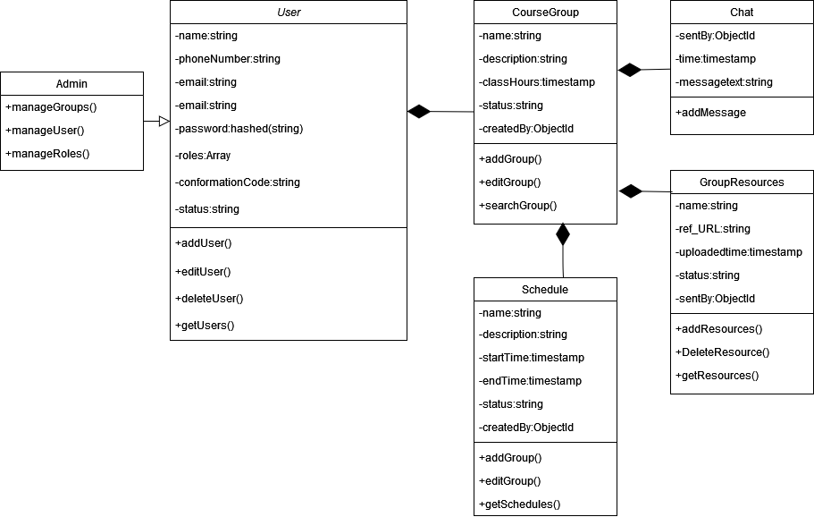

**Figure 3. Object Modeling using Class diagram**

#### ii. Dynamic modeling using State and Sequence Diagrams

**Figure 4. Sequence diagram**

#### 

#### 

#### iii. Process modeling using Activity Diagrams

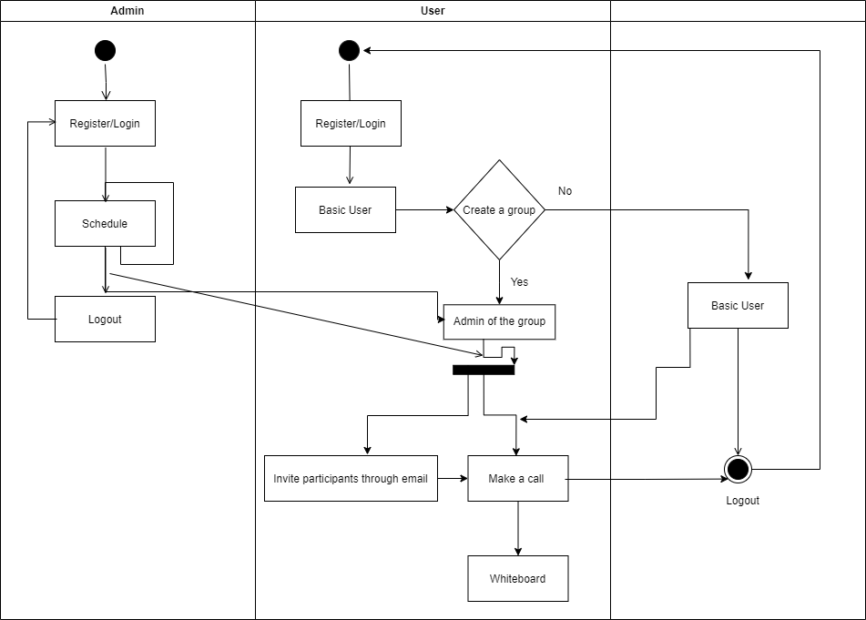

**Figure 5. Process Modeling Activity Diagram**

# Chapter 4: System Design

## 4.1. Design

The various components, modules, interfaces and data are decided in planning to provide a working framework for the project. It focuses on ‘how to accomplish the objectives of the system’. Our system design with analysis focuses mainly in:

• Systems

• Processes

• Technology used

For the design of the system, class and object diagrams along with sequence and activities diagrams are provided for object modeling , dynamic modeling and process modeling respectively.Similarly, the component diagram is designed to show different components present in the statement and how they interact with each other and the deployment diagram shows how the system is deployed in Heroku (free platform to host web apps ).

### 4.1.1. Object modeling using Class Diagrams



**Figure 6. Object Modeling using Class diagram**

### 4.1.2. Dynamic modeling using State and Sequence Diagrams

**Figure 7. Sequence diagram**

### 4.1.3. Process modeling using Activity Diagrams

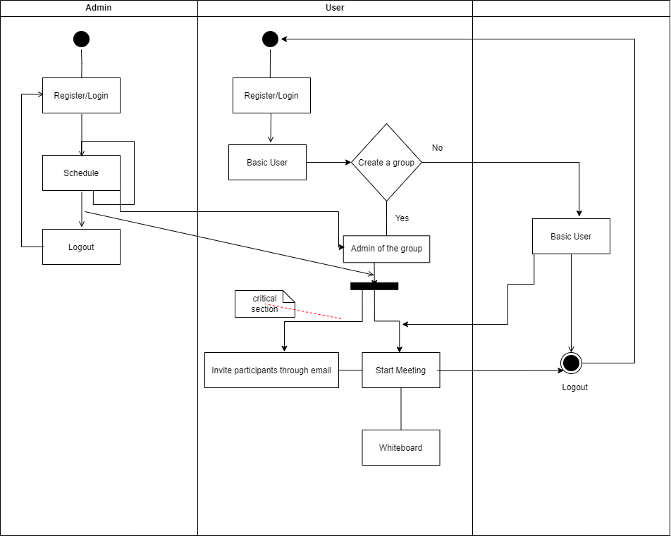

**Figure 8. Process Modeling Activity Diagram**

### 4.1.4. Component Diagram

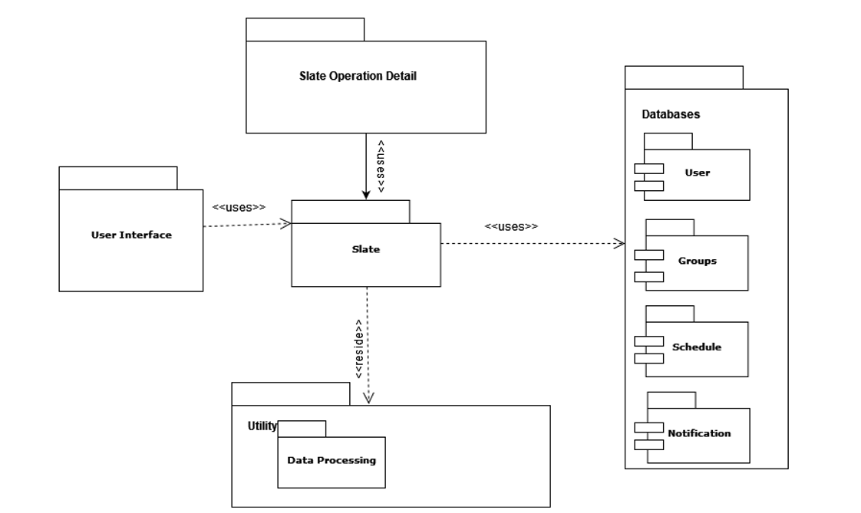

**Figure 9. Component Diagram**

### 4.1.5. Deployment Diagrams

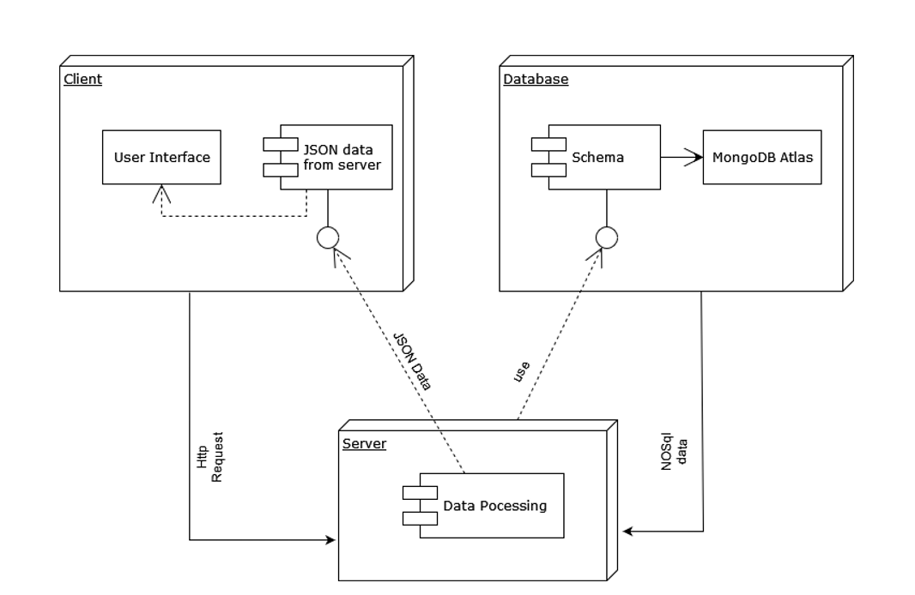

**Figure 10. Deployment Diagram**

## 4.2. Algorithm Details

### 4.2.1. LZW compression algorithm for data optimization

The LZW compression algorithm works by reading a sequence of symbols, grouping the symbols into strings, and converting the strings into codes. Because the codes take up less space than the strings they replace, we get compression. Characteristic features of LZW includes,

* LZW compression uses a code table, with 4096 as a common choice for the number of table entries. Codes 0-255 in the code table are always assigned to represent single bytes from the input file.
* When encoding begins the code table contains only the first 256 entries, with the remainder of the table being blanks. Compression is achieved by using codes 256 through 4095 to represent sequences of bytes.
* As the encoding continues, LZW identifies repeated sequences in the data and adds them to the code table.
* Decoding is achieved by taking each code from the compressed file and translating it through the code table to find what character or characters it represents.

#### i. LZW ENCODING PSEUDOCODE

1 Initialize table with single character strings

2 P = first input character

3 WHILE not end of input stream

4 C = next input character

5 IF P + C is in the string table

6 P = P + C

7 ELSE

8 output the code for P

9 add P + C to the string table

10 P = C

11 END WHILE

12 output code for P

#### ii. LZW DECODING PSEUDOCODE

1 Initialize table with single character strings

2 OLD = first input code

3 output translation of OLD

4 WHILE not end of input stream

5 NEW = next input code

6 IF NEW is not in the string table

7 S = translation of OLD

8 S = S + C

9 ELSE

10 S = translation of NEW

11 output S

12 C = first character of S

13 OLD + C to the string table

14 OLD = NEW

15 END WHILE

# Chapter 5: Implementation and Testing

## 5.1. Implementation

For system implementation , firstly, we studied all the information that was collected and then we analyzed and implemented a system in operation for both users and providers. Various tools and technologies have been used in order to develop the system, which are already discussed previously.

### 

### 5.1.1. Tools Used

**Design tools**

* Draw.IO
* Balsamiq
* Gleek.io

**Frontend and Backend Technology**

* Balsamiq
* HTML5
* CSS3
* Sass
* Material UI
* React.js
* Express.js
* Node.js

**Database**

* MongoDB

**Deployment and Management**

* Heroku
* Jira Project Management
* Github

# References:

* <https://en.wikipedia.org/wiki/WebRTC>
* <https://www.smartsheet.com/content/agile-gantt>
* <https://www.slideshare.net/PasinduTennage/sample-software-engineering-feasibility-study-report>
* <https://link.springer.com/chapter/10.1007/978-3-319-21067-4_28>
* [https://www.geeksforgeeks.org/lzw-lempel-ziv-welch-compression-technique](https://www.geeksforgeeks.org/lzw-lempel-ziv-welch-compression-technique/)